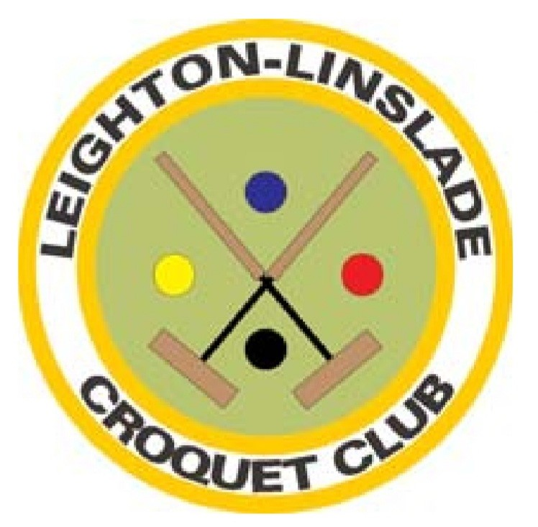
LEIGHTON-LINSLADE CROQUET CLUB
MEMBERSHIP APPLICATION FORM

PERSONAL INFORMATION
Name:
Address:
Postcode: |  | Phone (H): |  |  | Phone (M):
E-mail |  |  |  |  | Date:

Are you happy to share your details with other members of Leighton-Linslade Croquet Club (LLCC)? Enter Yes or No:

MEMBERSHIP OF CROQUET ENGLAND (CqE) AND DATA PROTECTION

Are you already a Standard Member of CqE? Enter Yes or No
Unless you are already a standard CqE member with another club, by joining LLCC you will become a Standard member. Please indicate your choice for the sharing of information by entering X in one of these boxes
(1) I want my details to be available to all members of CqE :
(2) I want my details to be available to the members of any clubs of which I am a member :
(3) I do not want my details to be available to anyone :

CLUB MEMBERSHIP FEE
The fee is made up of two parts: the basic fee and a levy which goes to CqE for your standard membership. If you are already a member of another club and pay the levy there you do not pay it again if you also join LLCC. There are reduced rates for younger members and students – contact the Membership Secretary (see below or the Contact Us page on the website) for details.

I want to join LLCC and pay the levy (£82.00 + £18.00 = £100.00) Enter Yes if applicable:
I want to join LLCC but already pay the levy at another club (£82.00) Enter Yes if applicable:

If you pay the levy at another club please enter name of club:

The completed Word form can be sent as an email attachment to our Membership Secretary : membership@leightonlinsladecroquet.org.uk. Please make payment by bank transfer to Leighton-Linslade Croquet Club, sort code 09-01-54, account 54393482.

